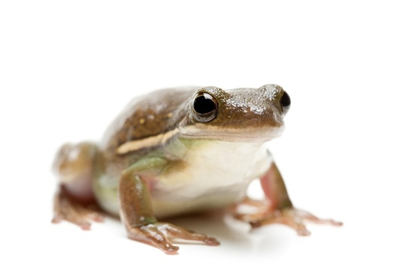
Ben’s Frog
Ben had a frog in a box.
The frog was little and green.
Ben found it in the park.
The frog was by a rock.
He gave it to his friend.

- What did Ben have?

——————————————————————-
- Where did Ben keep his frog?

——————————————————————-
- What colour was the frog?

——————————————————————
- Where did Ben find the frog?

——————————————————————

